- **Data Ingestion from CSV**

1. **Logic:**

* We have a csv file that needs to be loaded into a Table in Hive.
* For this we will use Spark and Python to write a script that will write a script and load data into the table.
* 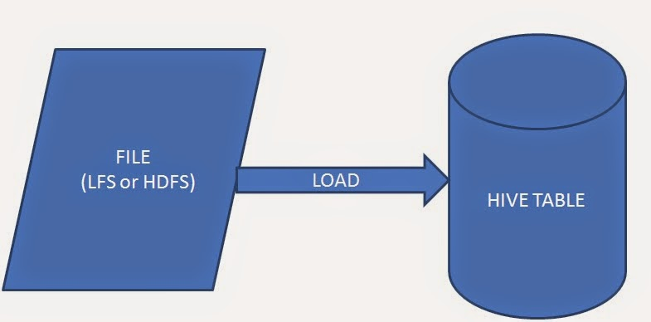The data type of the columns would be declared as String.

1. **Transformation:**

* Here we have a csv file named as ‘Anime’ which has all the details about animes broadcasting over the internet and TV.
* Its in order of anime, popularity, year and character.
* We have a requirement to get the data of the csv into a table in hive by transforming it based on Rating, Type and release year.
* Rating should be greater than 4.
* Type should be TV.
* And the Release year should be between 2019-2022.

1. **Note:**

* The python script is prepared by keeping in mind that we have installed connection hive and spark and they are configured.
* And an database should be there with the required name to publish the table.
* We can also create a table in Hive with different datatype and then load data into it by specifying each data type.